Voki Embedding

Index

1.Wix

2. Bravenet

3. Blogger

4. Moodles

5. PowerPoint

1. Wix

Step 1: Click on Add button from left menu bar and then on Embed a site tab from More options.

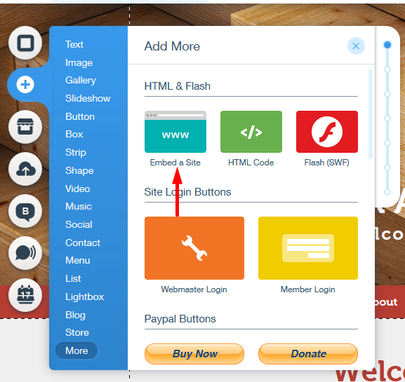

Step 2: Click on 'Enter website Address' and then on 'Code'.

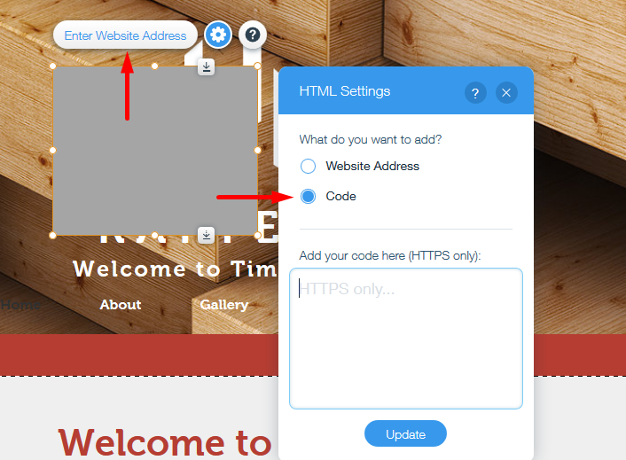

Step 3: Copy your embed code.

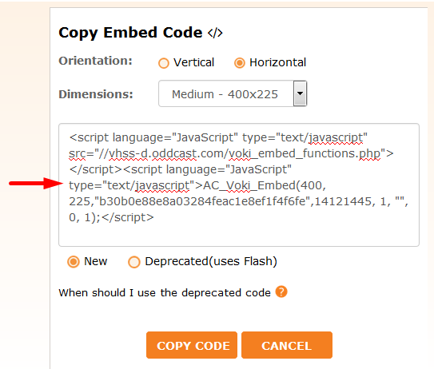

Step 4: Paste your embed code in the box including body tag and click 'Update' to save.

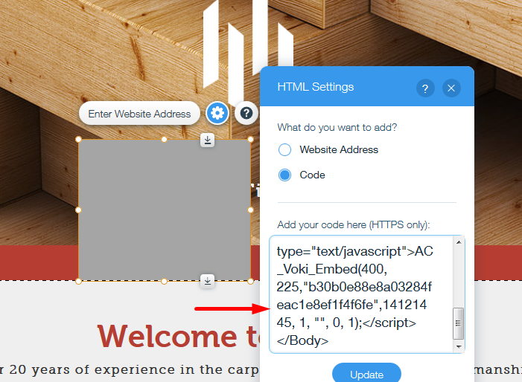

Step 5: Click on Preview to see your scene on page.

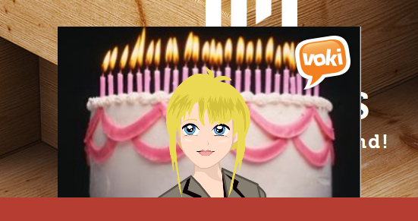

2. Bravenet

Step 1: Click on 'Add content/Layouts' button from top right.

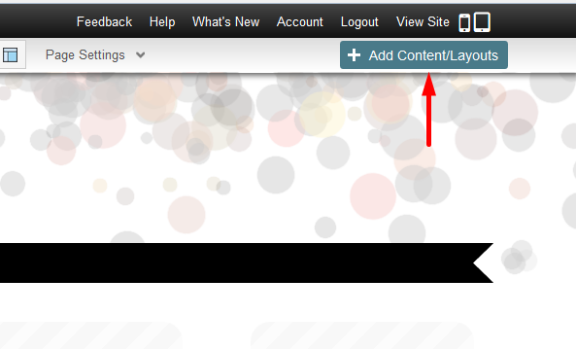

Step 2: Drag the Javascript/HTML tab on the page.
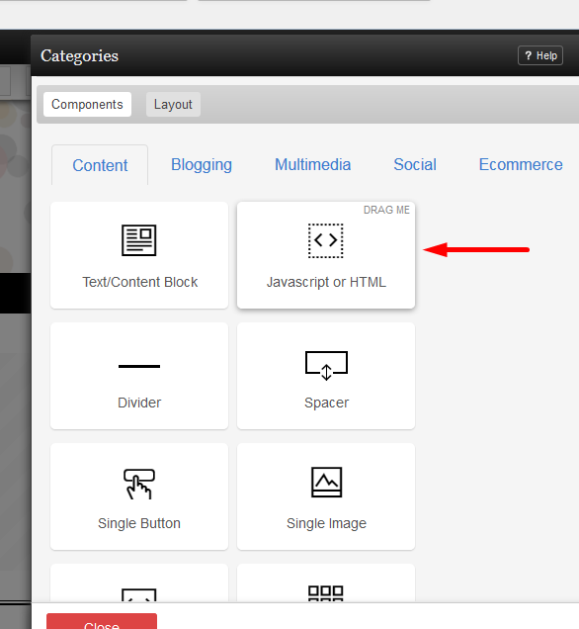

Step 3: Copy your deprecated voki embed code.

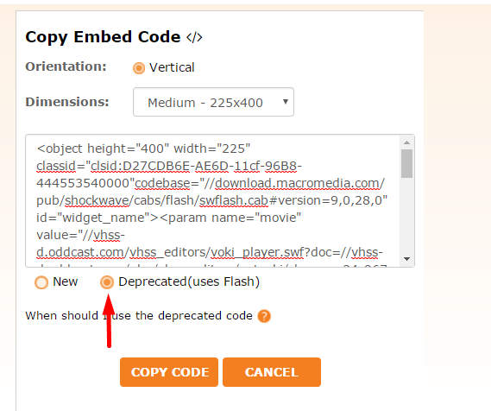

Step 4: Paste your embed code in HTML block.
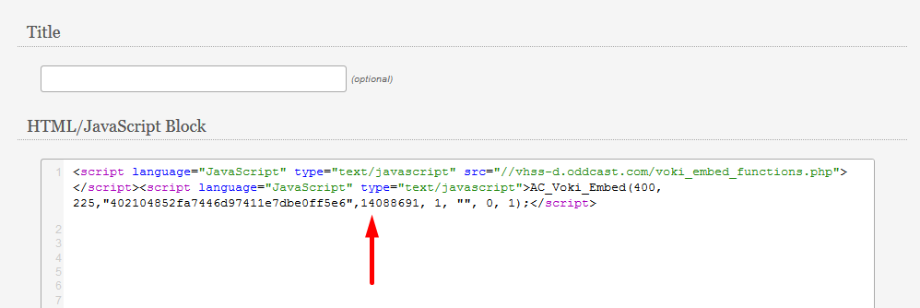

Step 5: Click on save button.

3. Blogger

Step 1: Goto Blog post and click on HTML button.

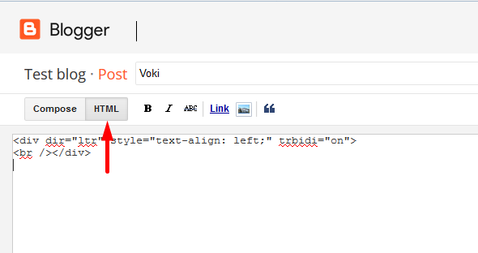

Step 2: Copy your voki embed code.

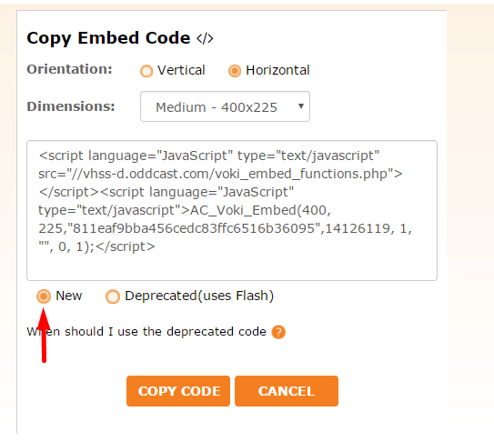

Step 3: Paste the embed code in HTML editor.

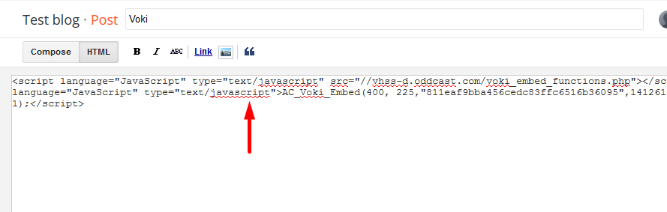

Step 4: Click on Save and Publish.

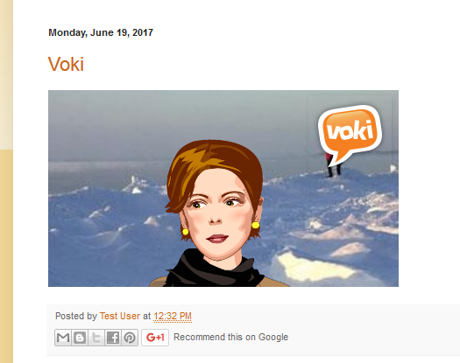

4. Moodles

Step 1: Open Moodles site page and turn editing on.

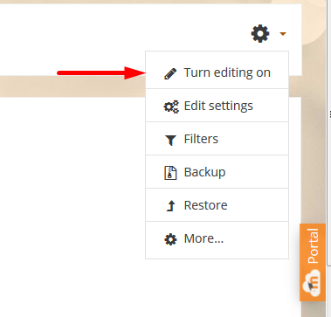

Step 2: Click on Add an activity or resource.

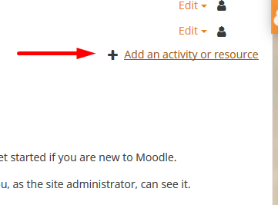

Step 3: Select Assignment from the activities options and click on Add button.

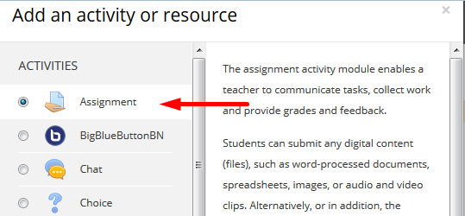

Step 4: Click on down arrow button then HTML button from description.

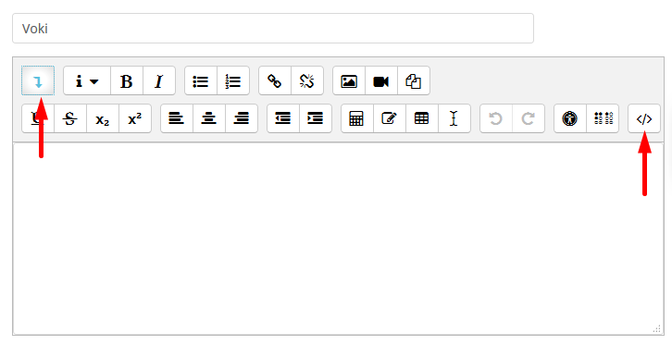

Step 5: Copy the Deprecated embed code of your voki.

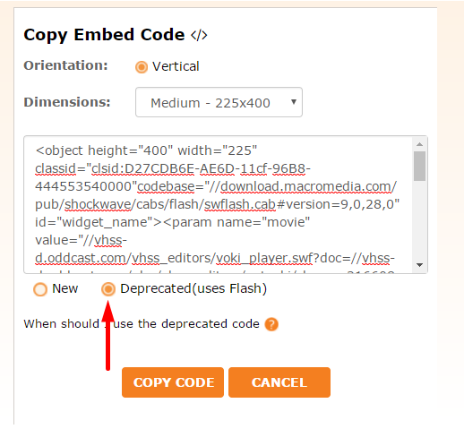

Step 6: Paste your embed code here.
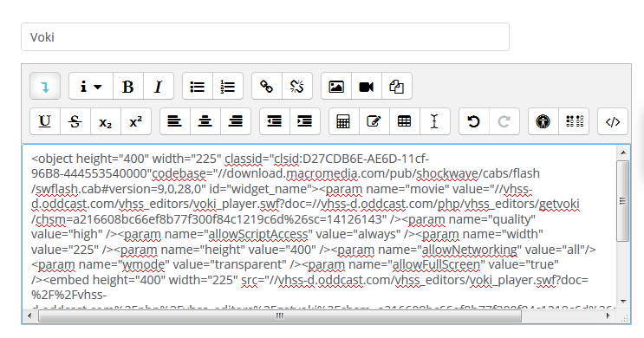

Step 7: Click on Save and Publish to preview.

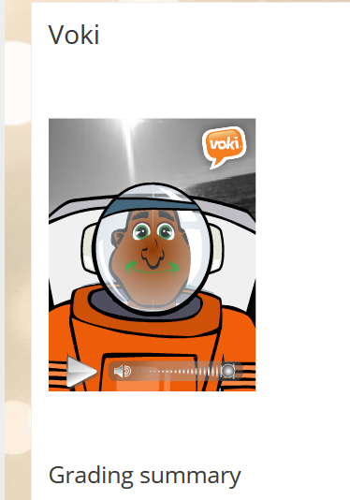

4. PowerPoint

Step 1: Copy the Deprecated embed code.

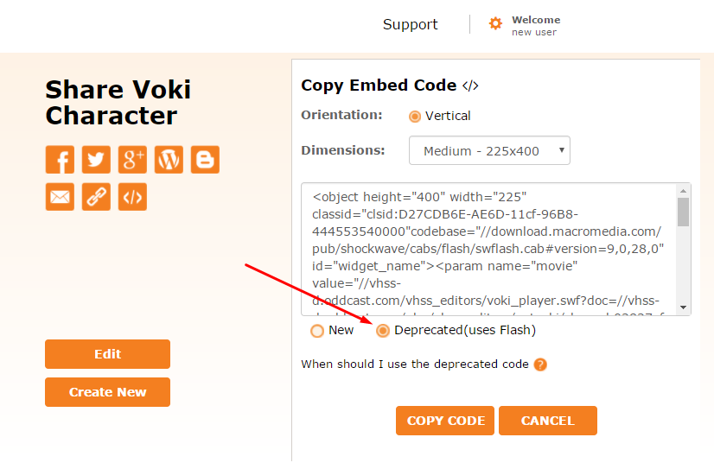

Step 2: Select the highlighted area from the embed code and copy.

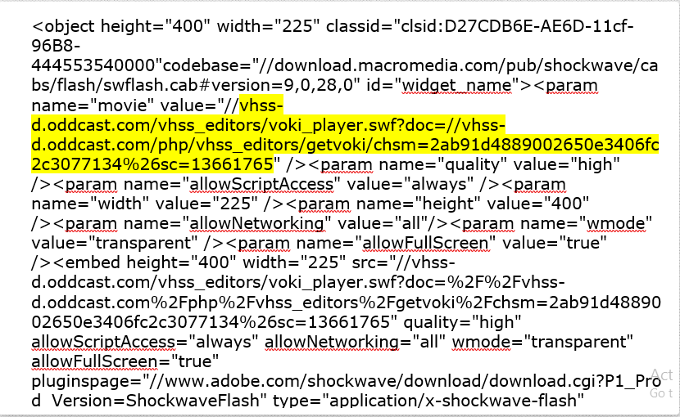

Step 3: Add https: in the beginning and in the middle of the selected code.

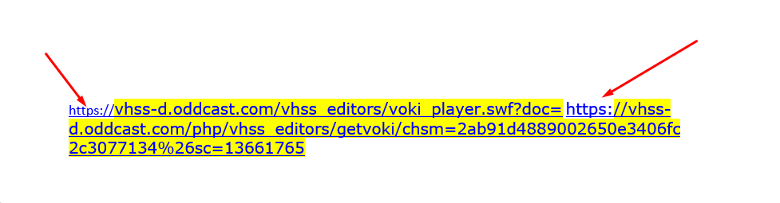

Step 4: Open Powerpoint 2016 and select the Developer option.

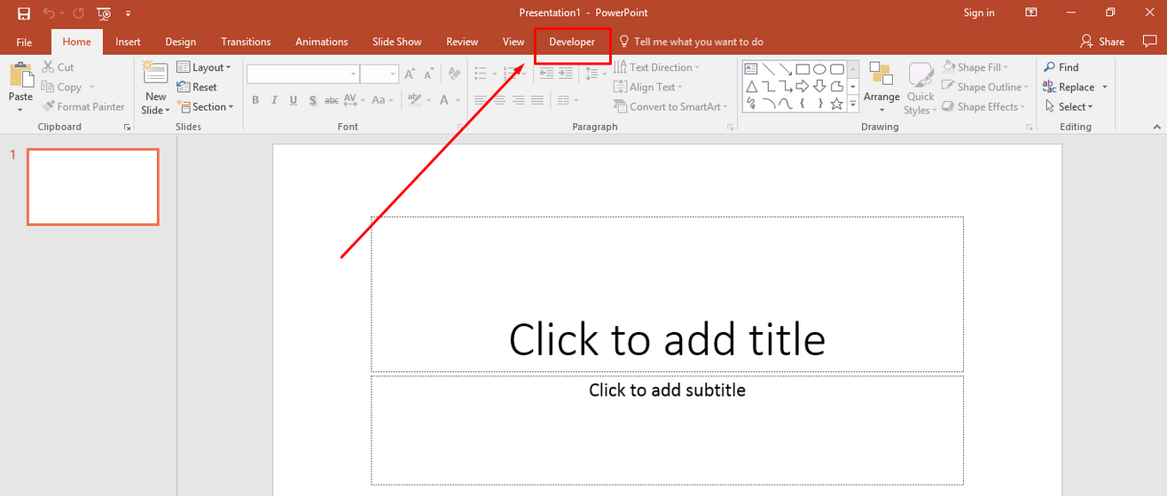

Step 5: Select More control option under Developer.

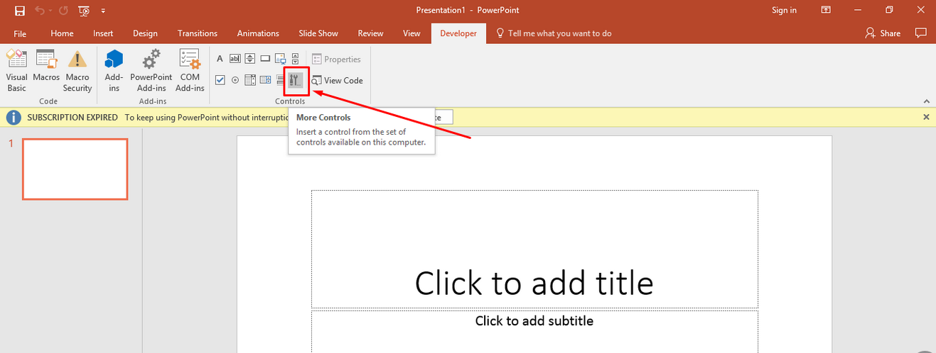

Step 6: Select Shockwave Flash object option.

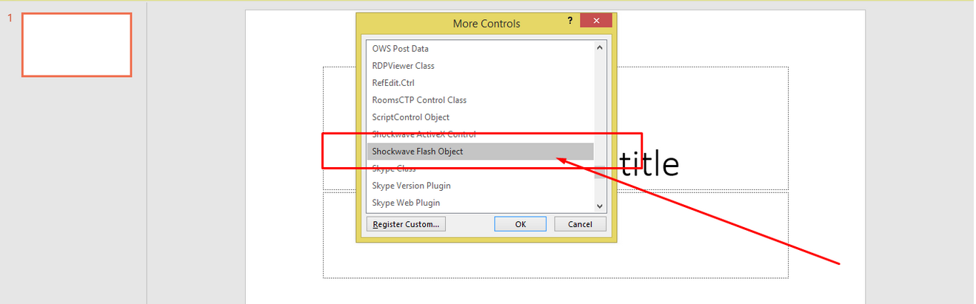

Step 7: Drag the box on the slide, right click on object and select Property sheet.

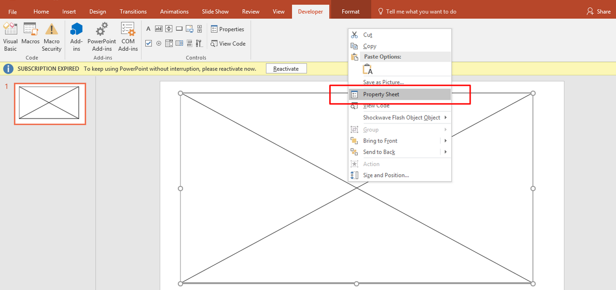

Step 8: Paste the selected code in Movie option and close the Properties.

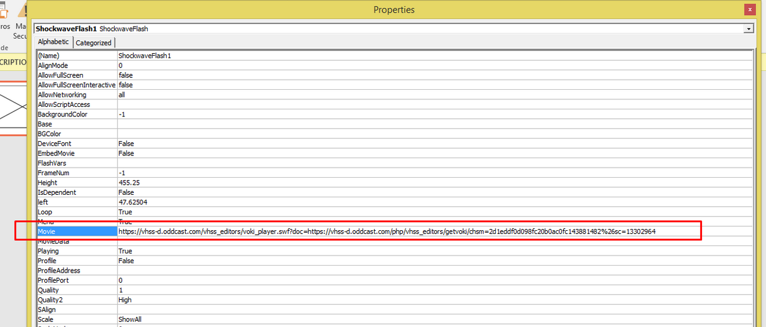

Step 9: Click on PowerPoint slide to view the scene.

