**1: Click on WordPress from Share Options:**

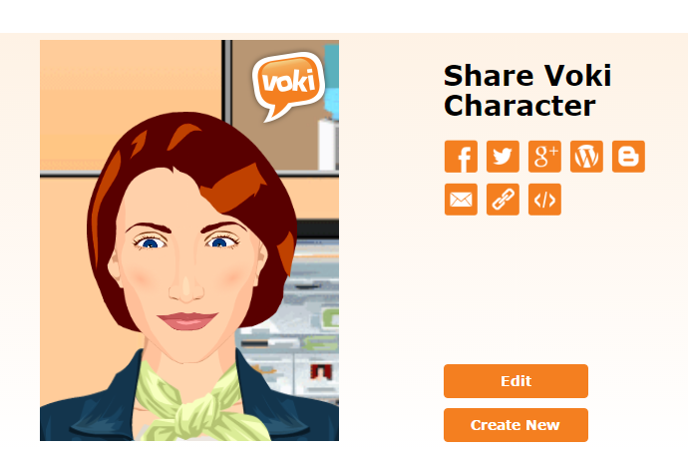

**2: Enter your Domain name or Webpage URL:**

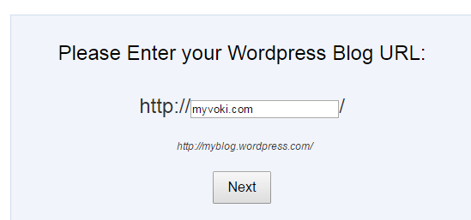

**3: Enter WordPress username and password:**

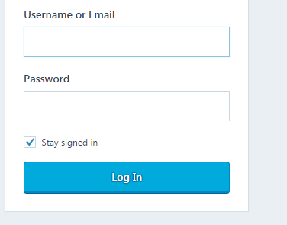

**4**. Click on the image:

